Web Toolkit

Administrator Manual

Table of Contents

Introduction 4

Company administration 4

Team administration 5

Create new team 6

Create team flow 6

Edit team information 7

Edit team information flow 7

Delete team 8

Delete team flow 8

Users administration 8

Invite users 9

Invite users flow 9

Soft delete user 11

Soft delete user flow 11

Edit user 12

Agenda 15

Edit agenda title/description flow 16

Create new section flow 17

Edit section 19

Delete section flow 19

Create new module 19

Create new module flow 20

Edit module flow 21

Delete module flow 22

Attendance 23

Create new meeting 23

Create new meeting flow 23

Previous meetings overview 24

Delete meeting flow 24

Strategic direction / Team documents 25

Create new link 25

Create new link flow 26

Link overview 26

Edit link flow 26

Delete link flow 27

Our current state / Our desired state / Learning modules 28

Our current state 28

Our desired state 28

Learning state 29

Save current state / desired state / learning state flow 29

Edit current state / desired state / learning state flow 30

Action plan 30

Create best contribution flow 30

Best contribution overview 32

Edit best contribution flow 32

Delete best contribution flow 32

Create area of improvement 33

Area of improvement and actions overview 34

Delete area of improvement flow 34

Create action flow 36

Edit action flow 37

Delete action flow 38

Filters 39

Filtering action plan flow 39

Log of ideas 40

Create idea flow 41

Edit idea flow 42

Delete idea flow 42

Convert idea to action 43

Targets and measurements 44

Add best contributions to track future measurements 44

Add best contributions to track future measurements flow 45

Edit best contribution end goal flow 45

Create new input 46

Create new input flow 46

Previous inputs overview 46

Delete input flow 47

Graph overview of previous inputs 47

Dashboard 48

Add new action/idea floating button 49

Switch language 50

Switch language 50

Help 50

## Introduction

This is the administrator manual for Web Toolkit, a web-based IT-solution developed by Integ Partner AB. Web Toolkit supports a way of working in an organization that is well aligned to the principles of Integral Management.

There are four different user roles in Web toolkit:

* *Super administrator* – This role is limited to Integ Partner staff and relates to the entire IT-system, such as setting up new organizations and setting roles for others
* *Company administrator*- This role has access to settings related to the organization using Web toolkit, such as setting up new teams or changing the Menu structure
* *Team administrator* – this role gives access to changes within a team, such as inviting new users or making changes to the user information
* *User* – this role gives access to all functionalities within a team such as actions and ideas as well as targets and measurements

The manual is intended for Company administrators and is divided into sections based on a typical implementation scenario:

* Company administration
* Team administration
* User administration
* Menu administration

Information on using Web Toolkit as a regular user can be found in “Web Toolkit User Manual”

## Company administration

Access to the Company administration is only granted to super administrators. To be able to access Company administration, you choose the “Company” option in the Administrator sub-menu.

Companies are presented in a form of a table, and each com has a title, details, edit and delete column. Companies are sortable by title. They are initially sorted in the ascending order. If you click on the arrow down icon  on the right side of the title, they will now be sorted in the descending order.

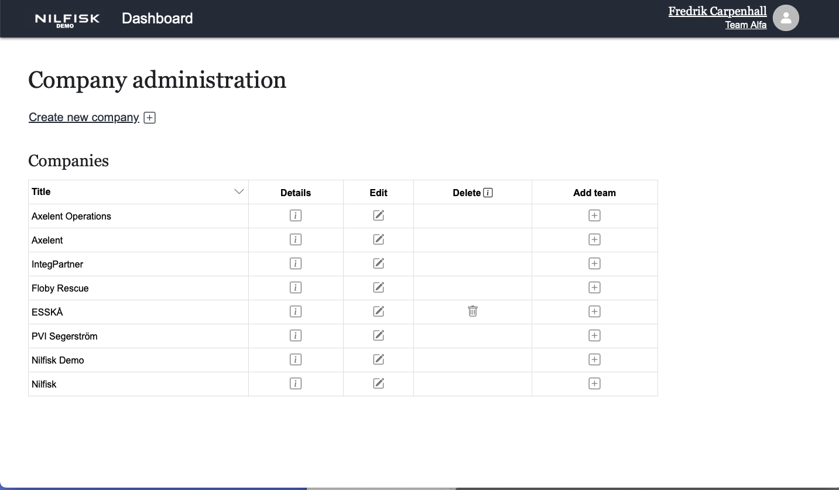

## Team administration

Access to the team administration is only granted to super administrators and company administrators. To be able to access team administration, you choose the “Teams” option in the Administrator sub-menu.

Teams are presented in a form of a table, and each team has a title, the company it is assigned to, edit and delete column. Teams are sortable by title and company columns. They are initially sorted in the ascending order. If you click on the arrow down icon  on the right side of the title or company, they will now be sorted in the descending order. Teams can be sorted either by title or company, but not by both at the same time.

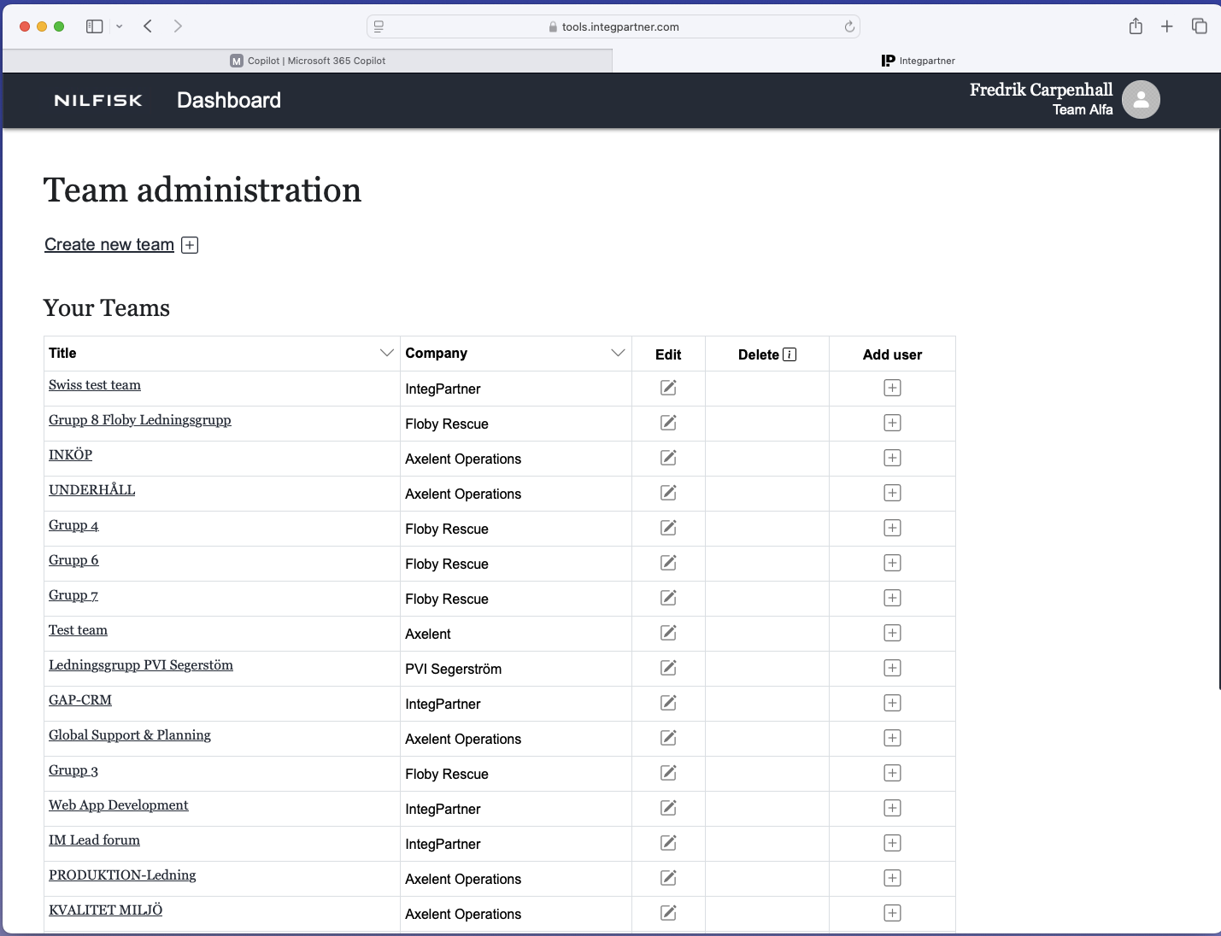

### Create new team

This option is available to Super and Company administrators.

#### Create team flow

* Click on the “Create new team” link

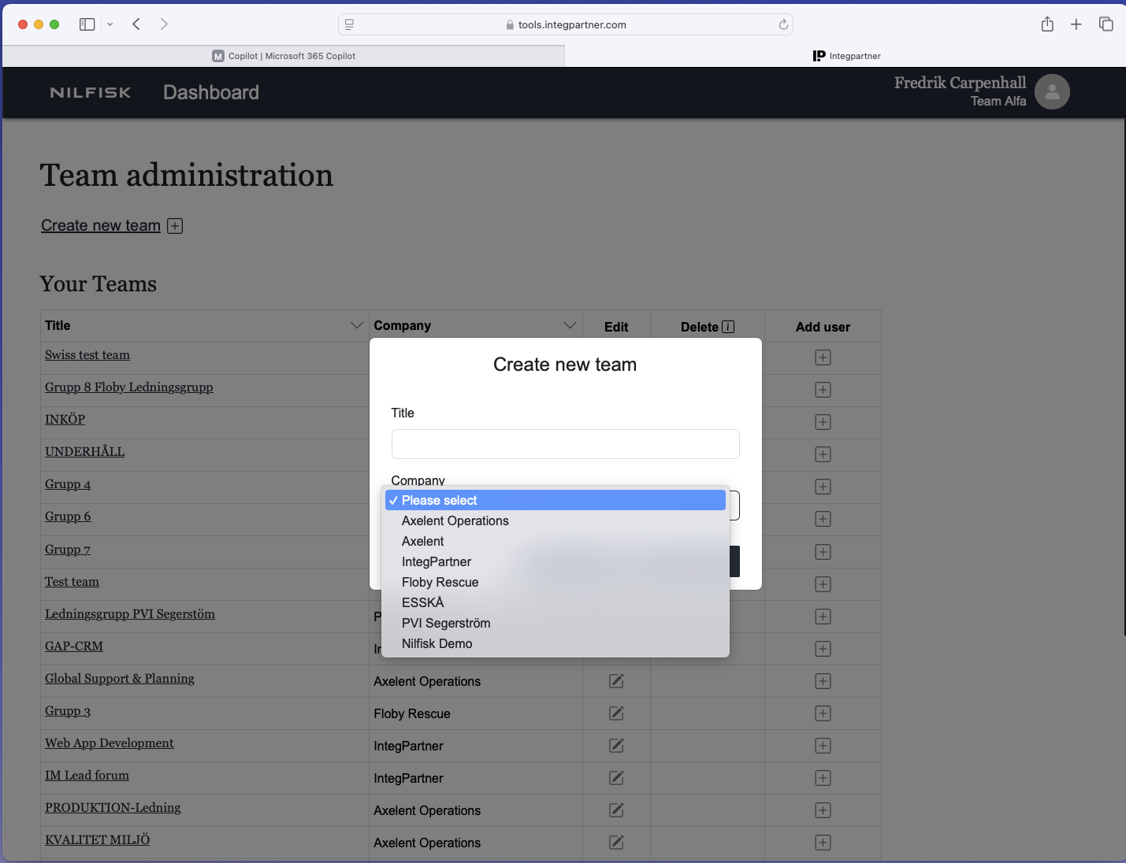

* A window opens up with a title field and a drop-down to select the company for which a team is being created

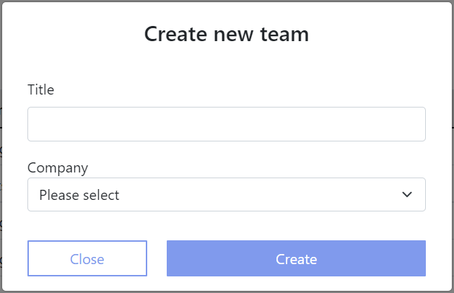

1. Enter team title and select the company (both fields are mandatory)
2. Clicks on the “Create” button and the window closes
3. The new team is created and is visible in the list of teams

### Edit team information

Both super administrator and company administrator have been granted rights to edit team information. The only difference is that super administrator can edit information of any existing team and company administrator can only edit information of teams that are part of the company they belong to.

#### Edit team information flow

* Clicks on the edit icon  in the column of the team they wish to edit

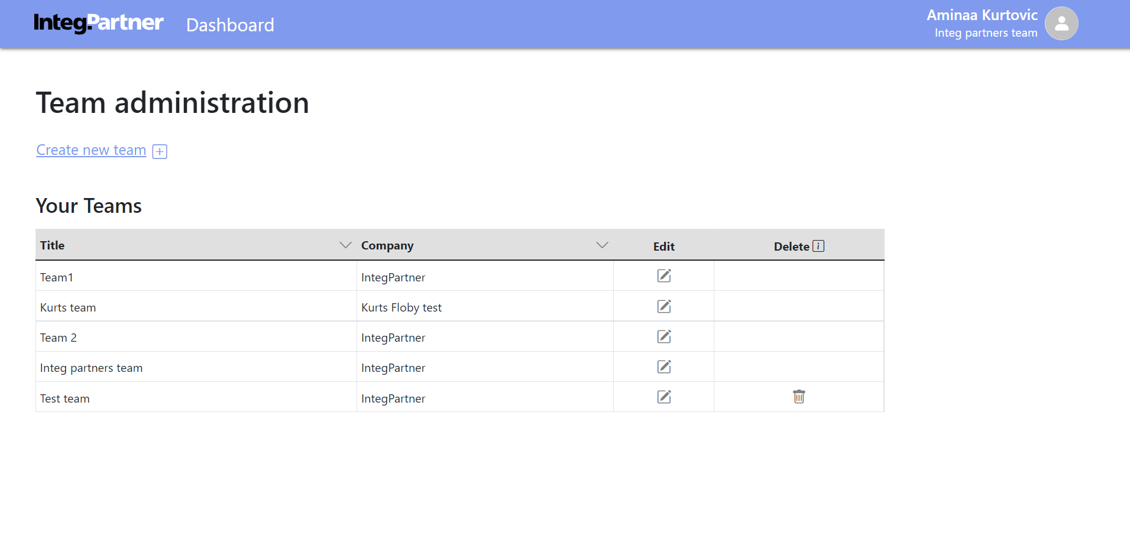

* A window opens up with team title field and company read-only field, there are also “Close” and “Save changes” buttons

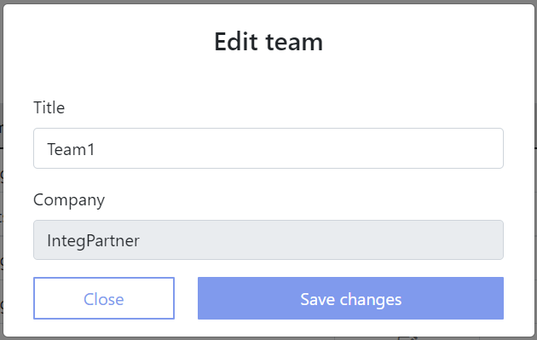

1. Enter team title and select the company (both fields are mandatory)
2. Clicks on the “Save changes” button and the window closes
3. The team information is changed

### Delete team

Both super administrator and company administrator are able to delete teams and they are able to do that if there are no users added to the team. If there are users added to the team, the delete icon  will not even be visible.

#### Delete team flow

* Click on the delete icon in the column of the team you wish to delete



* After the administrator clicks on the delete icon  , a small window with a warning message as follows shows up: “Are you sure you want to delete this team? The team will be permanently deleted. There are no users in the team.” Below this message there are two buttons visible: “Cancel” and “Delete anyway” button

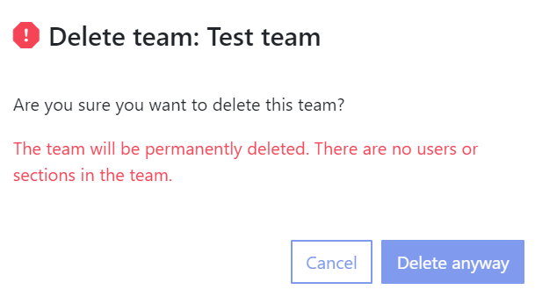

* Administrator confirms this action by clicking on the “Delete anyway” button
* The window is closed, and changes are saved

## User administration

Access to the user’s administration is available to all roles, including super admin, company administrator, and regular user. However, regular users have a different view of this section of the application. To access users’ administration, select the “Users” option in the Administration menu. After accessing the users administration section, users will find an "Invite users" link and a list of companies below it.

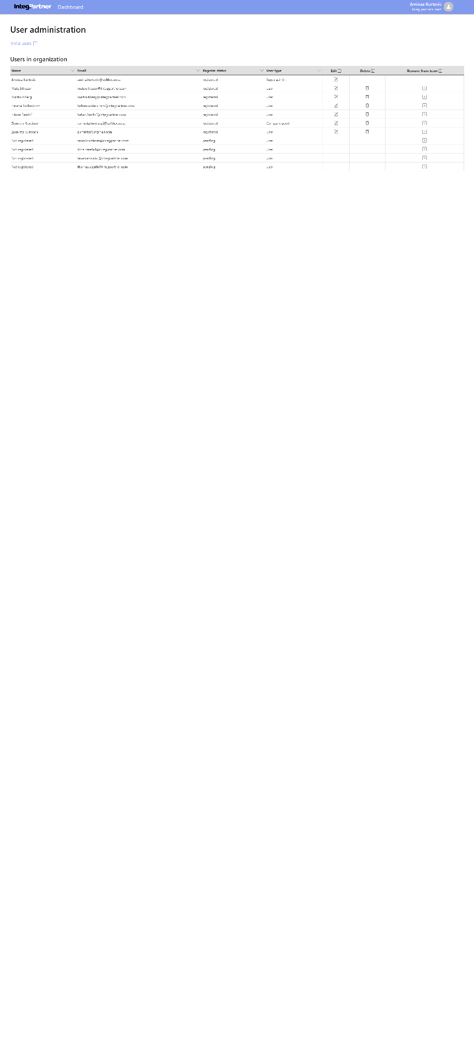

## Invite users

Admins cannot add users directly; instead, users are invited to join the team and complete the sign-up process. Super administrators are added manually to the database without needing to sign up. All users can send team invitations.

Company administrators are invited via the "Invite users" form and become regular users after signing up. They need to be promoted by a super administrator or company administrator to the role of company admin.

To add a user, invite them and they must complete the sign-up process. Initially, all users are assigned the role of regular user. The team they are invited to is the one they log into during the invitation process.

### Invite users flow

* User clicks on the “Invite users” link



A window appears for uploading user emails to a CSV file. Below it, there's a field to enter multiple invitee emails, along with read-only fields for company and team. The window includes "Close" and "Invite users" buttons.

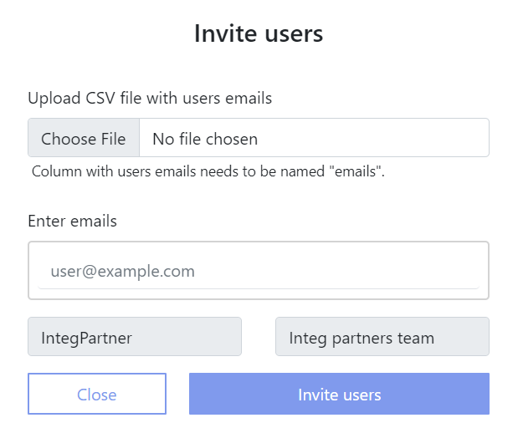

* User inputs emails of users they wish to invite (mandatory field)
* User confirms this action by clicking on the “Invite users” button
* Users are invited and emails are sent to them (now they are able to go through the sign up flow)

Users overview

Below the "Invite users" button is a table listing all previously invited team members. Super administrators or company administrators see these columns: name, email, register status (registered or pending), user type (super admin, company administrator, or regular user), edit, delete, and remove from team. Regular users don’t see the edit, delete, and remove columns. The table can be sorted by name, email, register status, or user type by clicking the arrow icon next to each column name. Initially, registered users appear at the top, followed by users with pending invitations. Only one column can be sorted at a time. For "name" and "email", users can be ordered ascending or descending. For "register status," users can be sorted with either pending or registered status on top. Sorting by "user type" allows super admins to be on top or regular users on top. Team leads have an icon beside their names.

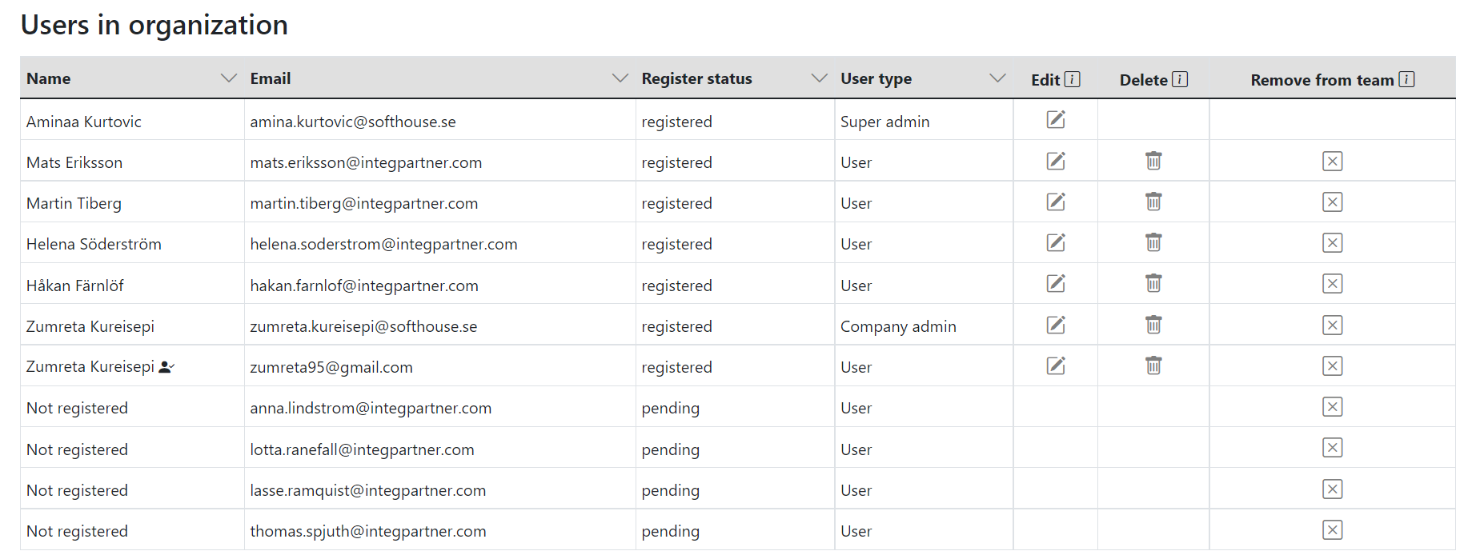

## Soft delete user

Soft deleting users only anonymizes users’ data, but they can still appear in different parts of the system in anonymized form. Only the super administrator and company administrator are able to soft delete users. Easiest way to recognize anonymized user is if there is a number of * characters instead of letters in their showcased data. Administrator is not able to delete themselves, users of higher status than them (company administrator can’t delete super admin) or users that are not registered yet. In these cases the delete icon  is not visible.

### Soft delete user flow

* Click on the delete icon  in the delete column of the user they wish to delete



* After the administrator clicks on the delete icon  , a small window with a warning message as follows shows up: “Are you sure you want to delete this user? The user will still appear in some places, but with anonymized information.” Below this message there are two buttons visible: “Cancel” and “Delete anyway” button

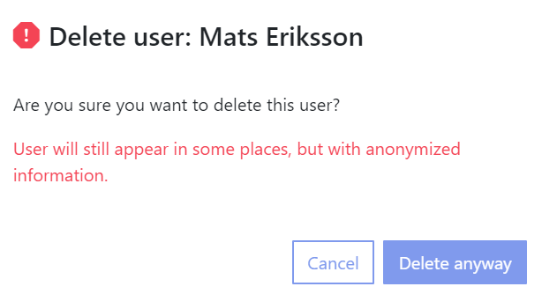

* Administrator confirms this action by clicking on the “Delete anyway” button and user is deleted
* Changes are saved and user is still visible in users table, but in anonymized form

## Edit user

Users are only editable if they are already registered. An administrator is not allowed to edit users with higher status than them (company administrator can’t edit super admin) or users that are not registered yet. Only through “Edit user” form admins are able to promote users from regular users to company admins. The reverse is possible as well. This form is the only part of the application where it’s possible to also mark users as team leads.

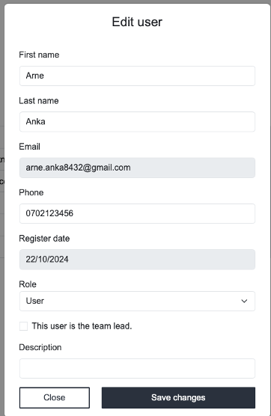

Edit User Flow:

* Click the edit icon next to the user they want to edit.
* A window opens with fields prefilled: first name, last name, read-only email, phone, read-only register date, a drop-down for role (read-only if user is a super administrator), "This user is the team lead" checkbox, description, plus "Close" and "Save changes" buttons.
* Make changes and confirms by clicking "Save changes".
* Changes are saved and displayed in the table of Users.

Remove User from Team:

* Only super administrators and company administrators can remove users but they cannot remove themselves.
* Click the remove icon next to the user they want to remove.

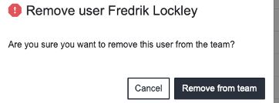

* A confirmation window appears with the message: “Are you sure you want to remove this user from the team?” with "Cancel" and "Remove from the team" buttons.
* Confirm by clicking "Remove anyway".
* User is removed and no longer visible in the User table.

Sign Up – Team Invitation:

* Super administrators can only be added manually to the database.
* Invitations are sent via email. The invited user follows the sign-up flow and becomes a regular user upon completion.

Sign Up Flow:

* Click "Join the team" button in the email.
* Sign-up form displays fields: first name, last name, phone, email (prefilled), password, confirm password, company (prefilled), and team (prefilled).
* After completing the form and clicking "Sign up", the user logs into the invited team automatically.

**Sign In**

When users log into `tools.integpartner.com` on one tab, they are automatically logged into all open tabs with the same address. To log into a different team, users can use an incognito window. If users belong to multiple teams, they will be signed into the last team they accessed.

**Sign-In Flow**

After entering “tools.integpartner.com” in the browser, the sign-in form with email and password fields is displayed.

Once all fields are completed and the user clicks the “Login” button, they will be logged in.

**Forgot Password – Change Password Flow**

Users can only change passwords if they have already completed the sign-up process.

**Change Password Flow**

The user clicks the “Forgot password” link on the sign-in form, and the reset password form with the email field is displayed. After completing the email field and clicking the “Send password reset email” button, the email is sent, and the user is notified by the “Check your email” screen.

Upon clicking the “Reset password” button in the received email, the “Change your password” form is shown with “new password” and “confirm password” fields.

After successfully filling out all fields and clicking the “Change password” button, a screen appears with the message “Your password has been changed successfully” and a button that leads to the login form.

# Agenda

The agenda is accessible through a sidebar located on the left side of the application once the user has logged in. Upon creating a new team, the initial agenda is automatically generated, including its sections and modules, which are listed below. Adjacent to the agenda title, there is a gear icon visible depending on the user's role. Regular users do not see this gear icon and are therefore unable to edit the agenda. Below the title, all sections along with their respective modules are clearly listed. All modules are clickable for further interaction.

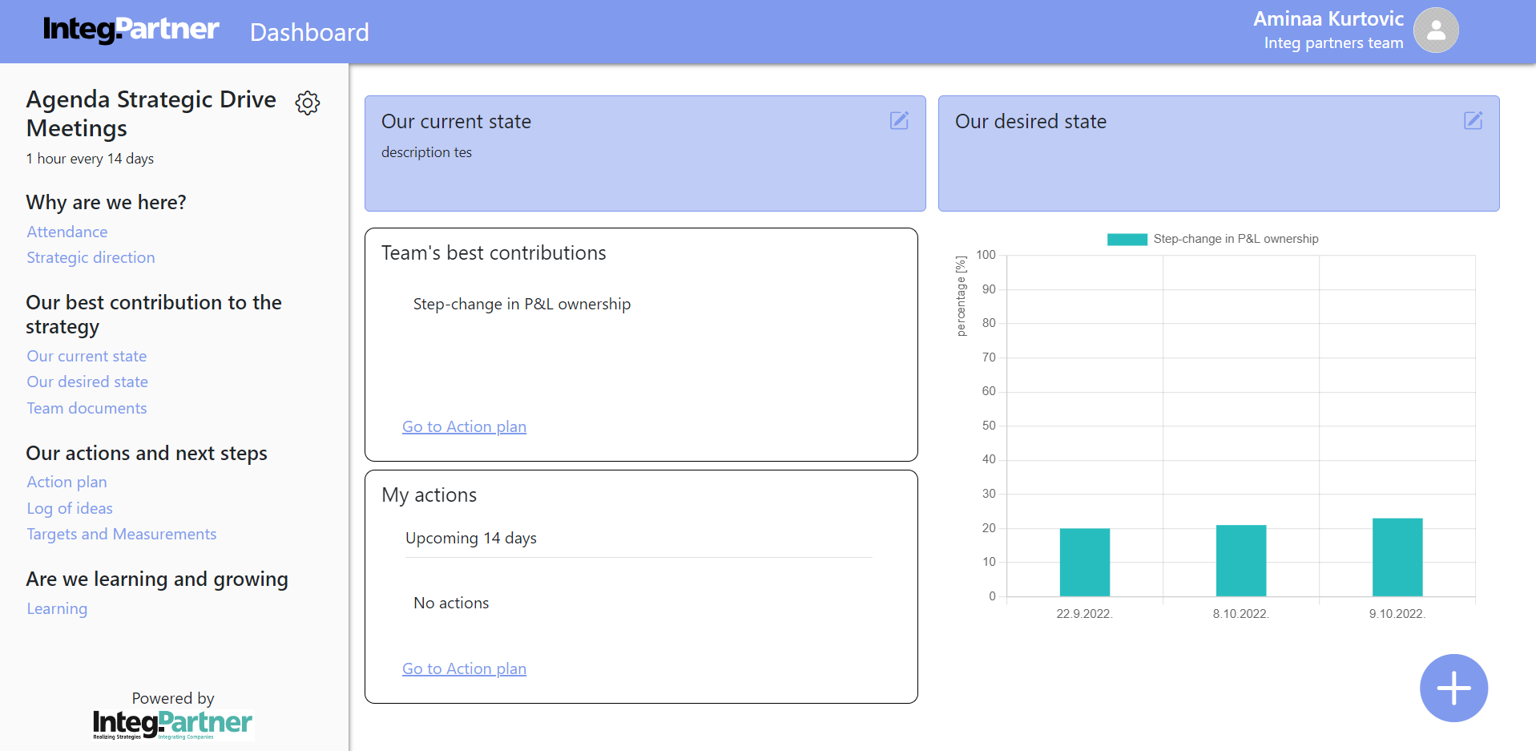

Only users with the roles of super administrator or company admin can perform agenda-related functions described in the following chapters. Clicking the gears icon next to the agenda title opens a window displaying: the team for which the agenda is used, the agenda title and description, and a list of sections with their modules.

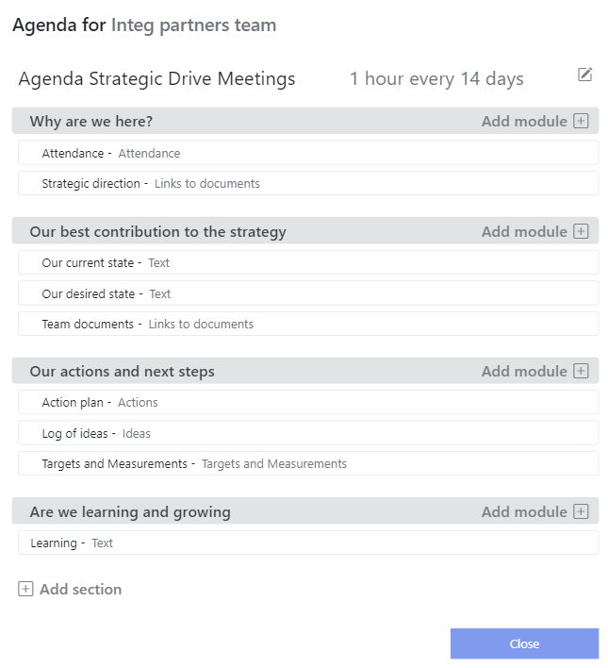

Changes made by an administrator to the current team's agenda will not affect other teams in the company. Accessing this form is a prerequisite for all agenda-related functions and will not be repeated in each process.

## Edit agenda title/description flow

* Click on the edit icon  on the right side of agenda title and description



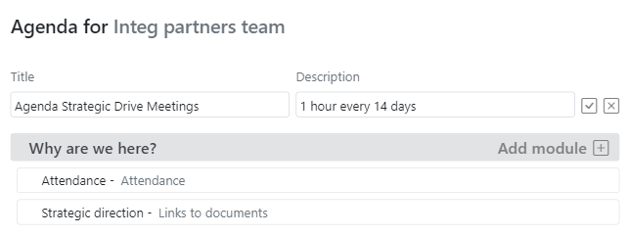

* Make intended changes
* Confirm changes by clicking on the checkmark icon 
* Changes are saved (changes are visible on the sidebar menu of the application) and editing mode is automatically exited

## Create new section flow

* Click on the “Add section” link on the bottom of the window below all sections and modules



* The field to input title of the section is displayed

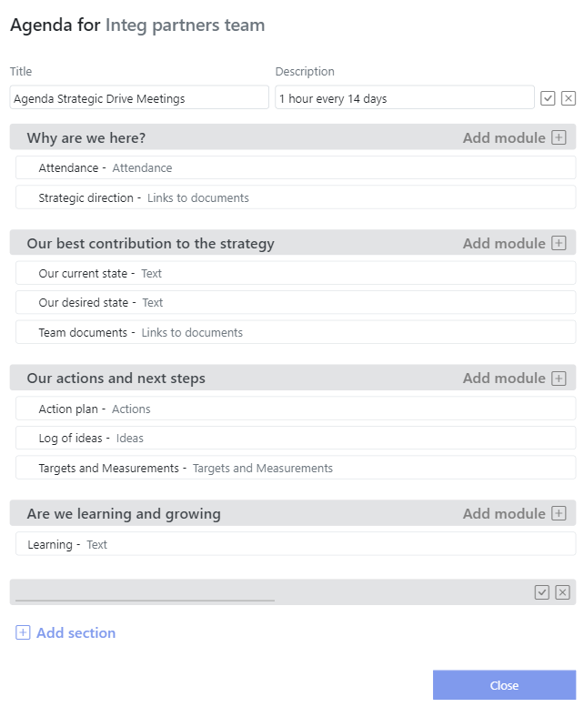

* Inputs intended section name
* Confirm action by clicking on the checkmark icon 
* Changes are saved and they are visible on the agenda as well as on the sidebar menu of the application

## Edit section

* Hover over the title of the section that they want to edit and edit and delete  icons are shown

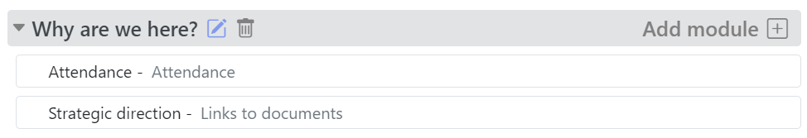

* After clicking on the edit icon  , editable field with current section title is shown



* Make intended changes
* Confirm changes by clicking on the checkmark icon 
* Changes are saved (changes are visible on the sidebar menu of the application) and editing mode is automatically exited

## Delete section flow

* Hover over the title of the section and delete icon  shows up along with the edit icon beside the title



* Click on the delete icon  section is automatically deleted
* Changes are saved and they are visible on the agenda as well as on the sidebar menu of the application

## Create new module

The types of modules that administrator can add are as follows:

* Ideas (user is able to add new ideas in the form of post it notes and later convert them to actions if they wish)
* Actions (actions module contains all the actions of the team split up by best contributions and areas of improvement)
* Attendance (module made to be able to track attendance of employees on the meetings along with the list of previous meetings)
* Links to documents (module made for users to be able to share relevant documents)

Modules for text, targets, and measurements cannot be added manually. They are auto-generated when the agenda is created. To add a new module, ensure the section exists or have the administrator add it to an existing section. If no section is present, the "Add module" feature will be inaccessible. However, sections with necessary modules are automatically generated after team creation.

### Create new module flow

* Click on the “Add module” link beside the name of the section 
* The field to input module’s name and drop-down to select module’s type become visible along with checkmark  and cancel  icon

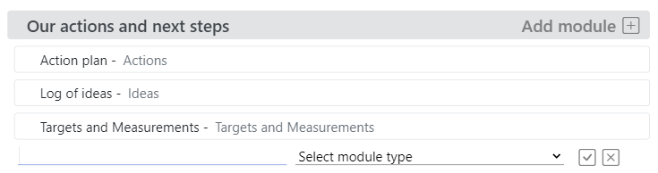

* Input module name and selects module type, then click on the checkmark  icon to confirm
* Changes are saved and they are visible on the agenda as well as on the sidebar menu of the application

## Edit module flow

* Hover over the title of the module that you want to edit  and edit and delete  icons are shown

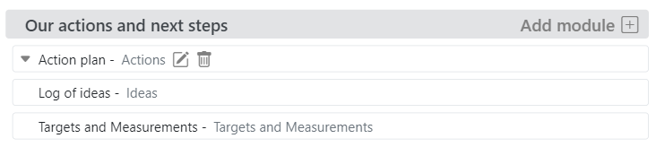

* After clicking on the edit icon  , an editable field with current module title is shown along with the module type (only name of the module can be edited, type cannot be edited since that would disturb data structure of the module and could cause data loss)

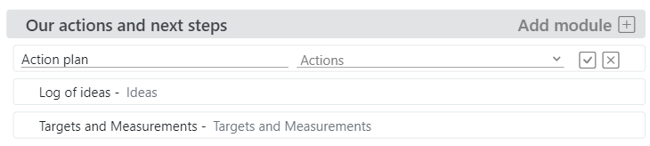

* Make intended changes
* Confirm changes by clicking on the checkmark  icon
* Changes are saved (changes are visible on the sidebar menu of the application) and editing mode is automatically exited

To change a module type, delete and re-add it with the desired type. Note that deleting a module will result in the loss of all its data.

## Delete module flow

* Hover over the title of the module and the delete icon  shows up along with the edit icon  beside the title



* Click on the delete icon  , a small window with a warning message as follows shows up: “Are you sure you want to delete this module? Module and data in it will be permanently deleted.” Below this message there are two buttons visible: “Cancel” and “Delete anyway” button

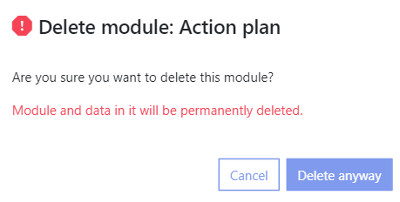

* Confirm this action by clicking on the “Delete anyway” button and the module is deleted
* Changes are saved and they are visible on the agenda as well as on the sidebar menu of the application

# Attendance

Access the Attendance module by clicking "Attendance" under the "Why are we here?" section on the sidebar. This module tracks team members' meeting attendance. Users can also add notes explaining attendance. Previous meetings are listed as well. All roles (super admin, company administrator, regular user) can perform actions in this module.

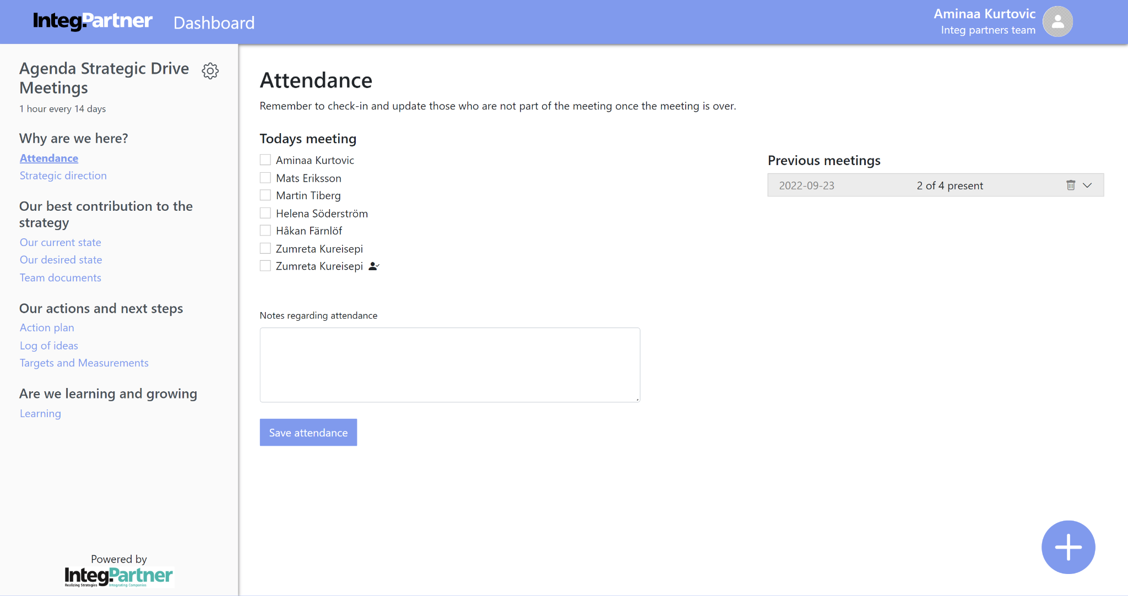

## Create new meeting

In the “Attendance” module, you can see a list of team members with checkboxes next to their names. The team lead is marked with an icon. Below the list, there is a textbox titled “Notes regarding attendance” for adding comments. The “Save attendance” button is at the bottom.

### Create new meeting flow

* The user selects all the team members that are present on the meeting from the list of the team members
* The user can add note to the notes textbox regarding attendance, but it’s not mandatory
* When the user clicks on “Save attendance” button the new meeting is saved and added on the top of the meeting list

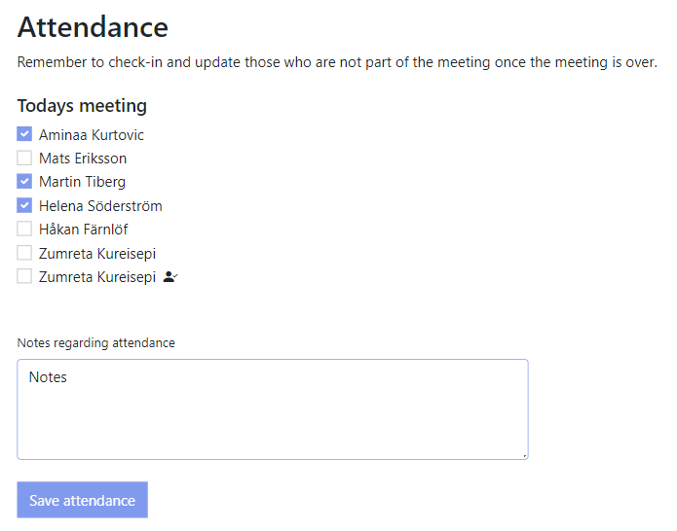

## Previous meetings overview

The previous meetings list is located on the right side of the attendance module, accessible via the sidebar. Meetings are sorted from most recent to oldest. Each entry shows the date and the number of attendees (e.g., 2 of 4). Meetings have a delete icon and an arrow down icon. Click the arrow down icon to reveal attendees; multiple meetings can be expanded simultaneously. Click the arrow up icon to collapse an expanded meeting.

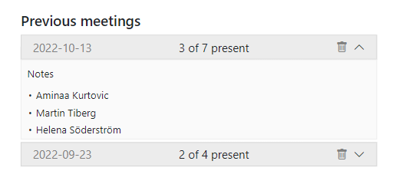

## Delete meeting flow

* The User clicks on delete icon  on the right side of the meeting that they wish to delete from the list of meetings



* When the user clicks on the delete icon  , a small window with a warning message as follows shows up: “Are you sure that you want to delete this input?” Below this message there are two buttons visible: “Cancel” and “Delete anyway” button
* The user confirms this action by clicking on “Delete anyway” button and meeting is deleted
* The changes are saved and meeting is no longer visible on the meetings list

# Strategic direction / Team documents

Modules with links to documents can be found by clicking on the “Strategic direction” link under the “Why are we here?” section on the sidebar or the “Team documents” link under the “Our best contribution to the strategy” section. After selecting either the “Strategic direction” or “Team documents” link, a module containing document links is displayed. The purpose of these modules is to share team-relevant and strategic documents and make them easily accessible to all team members. Users can have any role supported in the system (super admin, company administrator, or regular user) and perform actions related to this module.

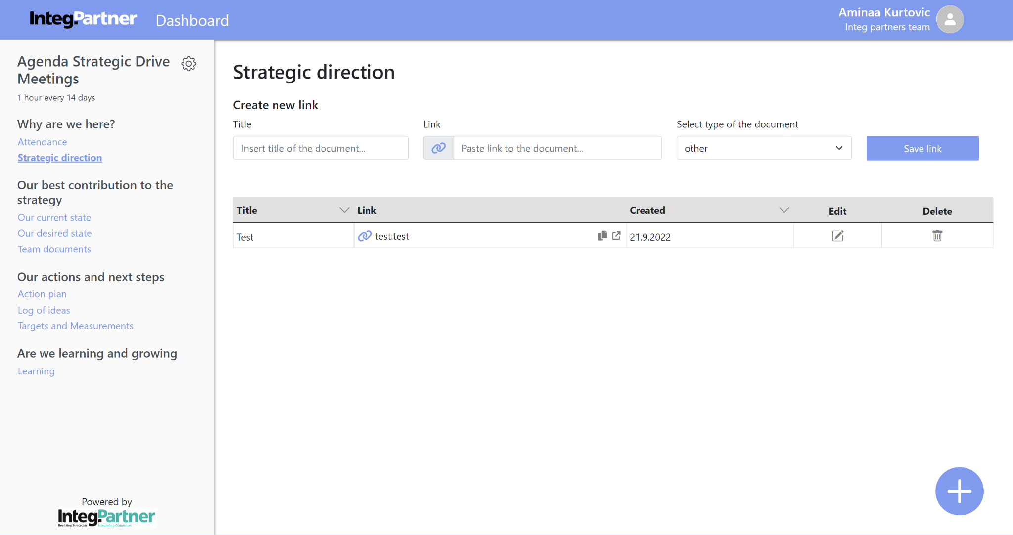

## Create new link

Once accessed, users see a form under the module title to create a new link. The form includes fields for the link title, URL, and a document type dropdown. A “Save link” button is on the right. Document types available are:

* Microsoft Word documents (doc or docx in the drop-down)
* PDF documents (pdf in the drop-down)
* PowerPoint documents (ppt and pptx in the drop-down)
* Excel documents (xls and xlsx in the drop-down)
* CSV document (csv in the drop-down)
* Other types of documents (other in the drop-down)

The document type is chosen automatically based on the link extension, defaulting to "other" if unsupported. Users can manually change the document type regardless of the extension. An appropriate icon will display next to the link if supported; otherwise, an attachment icon will appear.

### Create new link flow

* The user fills out link title, link and selects the type of the document in the form (link title and actual link are mandatory fields). Link needs to be in one of the following formats: [www.url.com](http://www.url.com), <https://url.com>, <https://www.url.com>, [http://url.com](https://url.com), [http://www.url.com](https://www.url.com), [url.com](http://url.com).

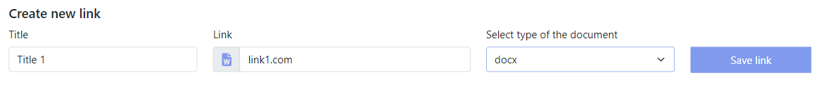

* The user confirms this action by clicking on the “Save link” button
* A message pops up with the following content: “The data successfully saved”
* The link is added to the list of links below the form

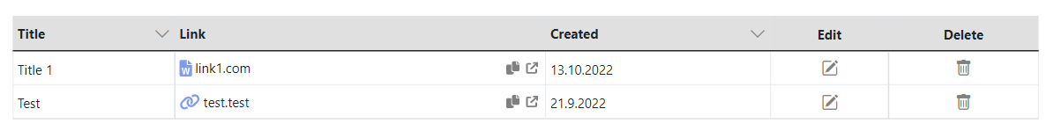

## Link overview

Below the one-line form for creating new links is a table listing all previously added links. Each entry in the table displays the title of the link, the actual link, the date it was created, as well as edit and delete icons. Links can be sorted by title and creation date. An arrow next to the column names for link title and creation date indicates the sort order (initially pointing down for descending order). To sort links in ascending order by title or creation date, users can click the arrow to change its direction upwards. The table supports sorting in ascending order by only one column at a time. Each link can be opened in a new tab by clicking the designated icon or copied to the clipboard by clicking another icon.

## Edit link flow

* The user clicks on the edit icon  in the row of the link in the links table that they wish to edit



* A window opens up with link title and actual link editable fields along with the drop-down to be able to change the type of link, on the bottom of the window there are “Cancel” and “Save changes” buttons

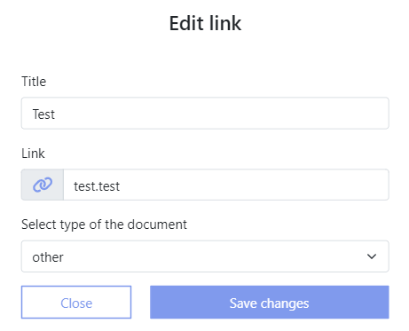

* The user makes intended changes
* The user confirms this action by clicking on the “Save changes” button
* A message pops up with the following content: “The data has been successfully updated!”
* Changes are saved and they are visible in the links table

## Delete link flow

* Click on the delete icon  in the row of the link in the links table that you wish to delete



* When clicking on the delete icon , a small window with a warning message as follows shows up: “Are you sure you want to delete the selected link? The data will be permanently gone.” Below this message there are two buttons visible: “Cancel” and “Delete anyway” button

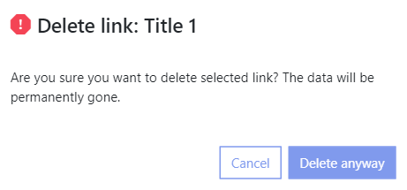

* Confirm this action by clicking on the “Delete anyway” button and the link is deleted
* Changes are saved and link is no longer visible in the links table

# Our current state / Our desired state / Learning modules

The chapters will describe the purpose of three text type modules: our current state, our desired state, and learning. These are the only text type modules in the application's current version. Each module includes a title, a description, a textbox, and a save button. Users can have roles such as super admin, company administrator, or regular user and perform actions related to these modules.

## Our current state

The "Our current state" module is located under the “Our best contribution to the strategy” section in the sidebar. Click on the “Our current state” link to access it. This module includes a description asking, “Enter a description of how you feel that the situation is today, where to start from?” Below the description, there is a textbox and a save button.

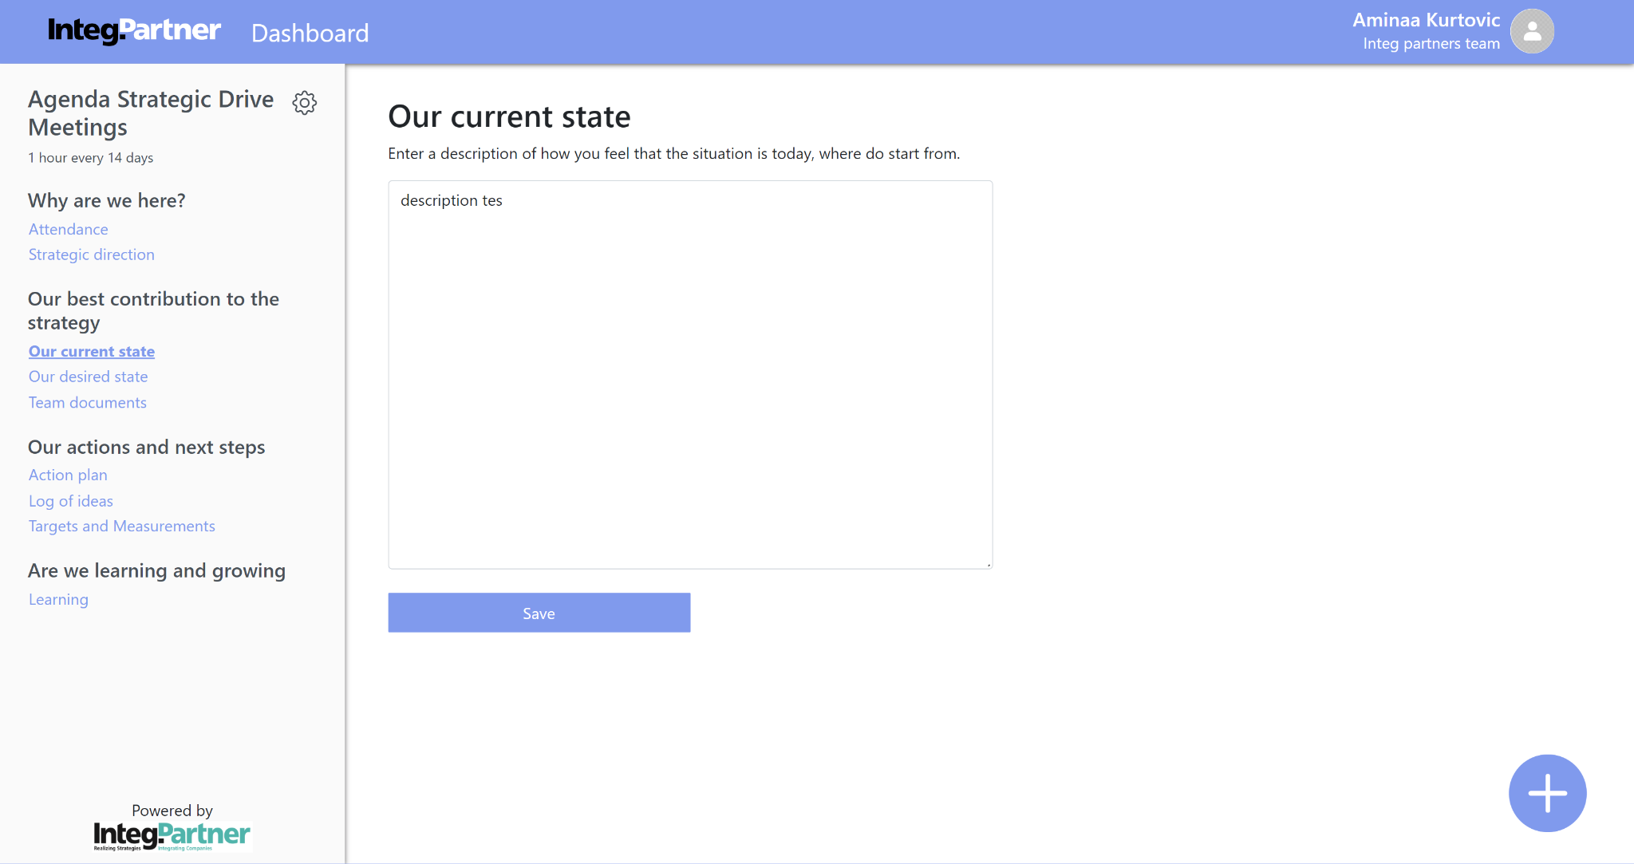

## Our desired state

The "Our Desired State" module is located under the "Our Best Contribution to the Strategy" section in the sidebar. By selecting the "Our Desired State" link, this module becomes accessible (this step precedes all subsequent functionalities related to the text type modules for which the workflows will be described and will not be included in the workflows). The module includes a description beneath the title, stating: "Enter a detailed description of your envisioned situation upon achieving your goal for this period." Below this description, there is a textbox and a save button.

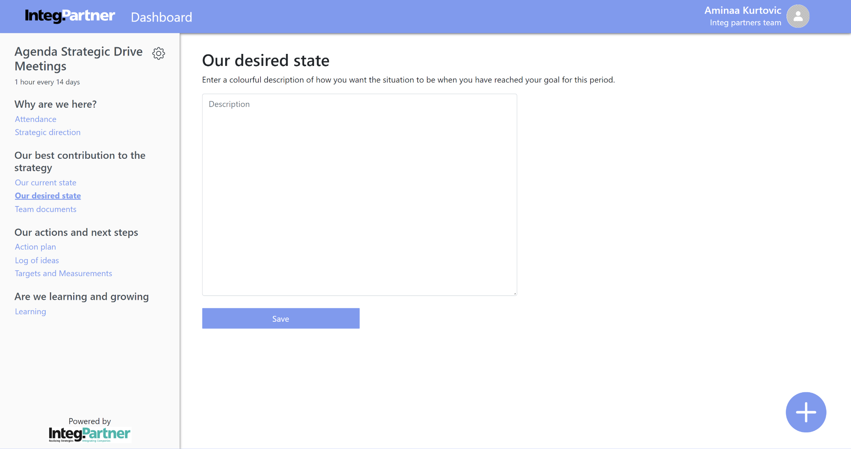

## Learning state

The "Learning" module is under the "Are we learning and growing" section on the sidebar. Click "Learning" to access the module. It includes a description: "Please document your learnings per meeting in chronological order." Below this, there is a textbox and a save button.

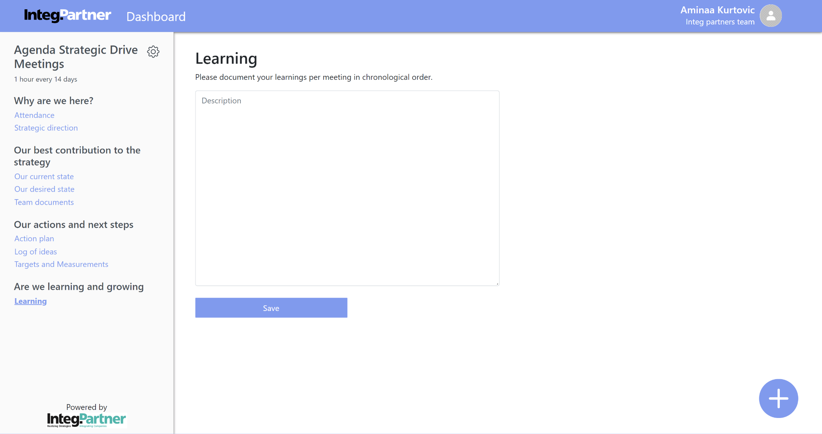

## Save current state / desired state / learning state flow

* After the user has accessed the module they can input desired text in the textbox



* By clicking on the “Save” button data is saved and a message pops up to inform the user about successful action (“The data successfully saved!”)

## Edit current state / desired state / learning state flow

* Make intended changes
* By clicking on the “Save” button changes are saved and a message pops up to inform user about the successful action (“The data successfully saved!”)

# Action plan

Access the action plan by clicking on the “Action plan” link in the “Our actions and next steps” section on the sidebar. The module includes best contributions with areas for improvement, each containing actions/tasks assigned to team members. This module provides an overview of the team's goals, progress insights, and responsibilities. All user roles (super admin, company admin, regular user) can access the action plan and its functionalities.

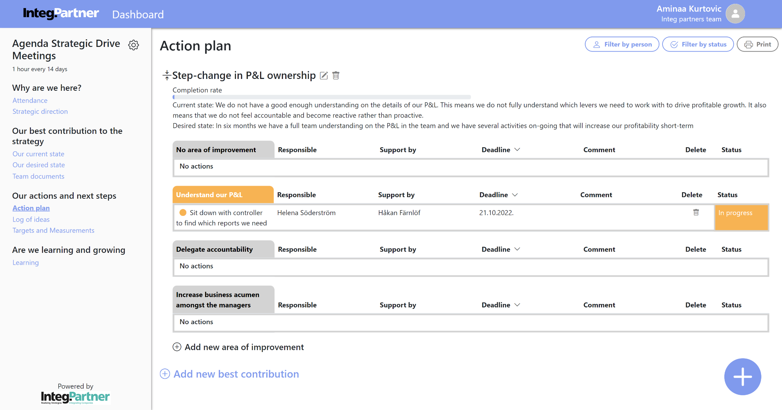

Figure 73

## Create best contribution flow

* Click on the “Add new best contribution” link on the bottom of the module below all best contributions



* A Window is shown containing following fields: title, current state, desired state and slider that indicates the completion rate of the best contribution along with the “Close” and “Save” buttons

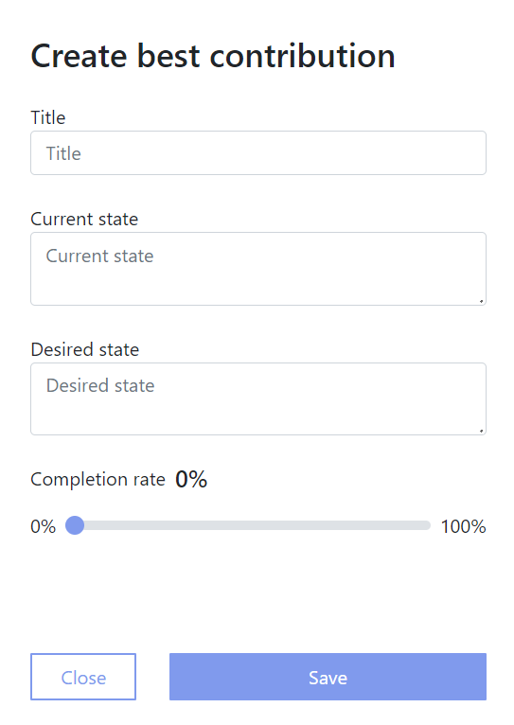

* Input desired data (only mandatory field is best contribution title)
* Confirm this action by clicking the “Save” button
* The data is saved and newly created best contribution is visible in the list of best contributions in the action plan

When a new best contribution is created, an "No area of improvement" entry is added. These entries track actions without a specified area of improvement.

## Best contribution overview

The action plan lists the team's best contributions, each with a title, edit and delete icons, completion rate, current state, desired state, and areas for improvement with actions. Contributions are initially expanded but can be collapsed by clicking the icon on the left of the title. Each contribution has an "Add new area of improvement" link below it.

## Edit best contribution flow

* Click on the edit icon  on the right side of the title of best contribution that you wish to edit and the window opens with the best contribution data

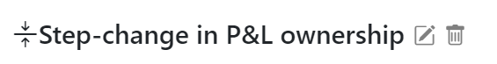

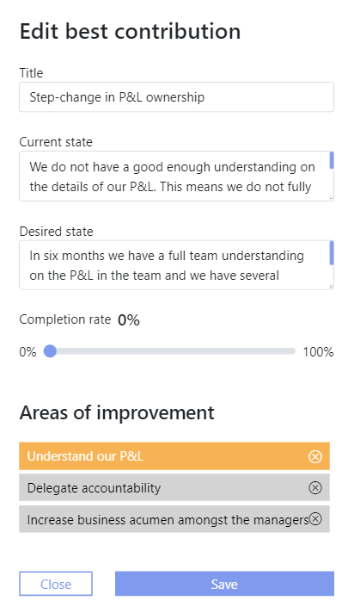

* Make intended changes
* Confirm this action by clicking on the “Save” button
* The form is automatically closed and changes are saved and visible on the action plan

## Delete best contribution flow

* Click on the delete icon  on the right side of the title of the best contribution that you wish to delete



* After clicking on the delete icon , a small window with a warning message as follows shows up: “Are you sure you want to delete this best contribution? Best contributions and areas of improvement along with the actions in it will be permanently deleted!” Below this message there are two buttons visible: “Cancel” and “Delete anyway” button

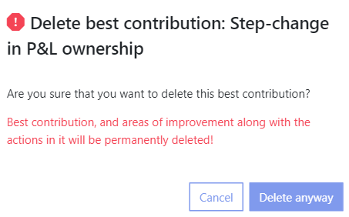

* Confirm this action by clicking on the “Delete anyway” button and best contribution, areas of improvement and actions that are connected to them are all deleted
* The canges are saved and they are visible on the action plan

## Create area of improvement

* Select “Add new area of improvement” link below the best contribution to which you want to add new area of improvement to along with the “Close” and “Save” buttons



A new area for improvement is introduced, accompanied by a field for users to enter a title.

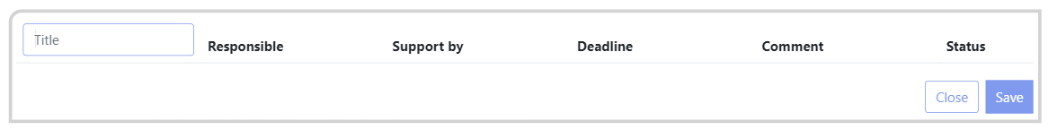

* Enter the title
* After the user clicks on the “Save” button changes are saved and a new area of improvement is added and visible on the action plan

## Area of improvement and actions overview

Each contribution has specific areas for improvement that help achieve the main goal. Each action within an area of improvement includes: Description, responsible team member, support team member, deadline, comment, and status. Actions can be sorted by deadline in descending or ascending order by clicking on the arrow icon next to the deadline column title. An area of improvement may be titled “No area of improvement” if no specific area was chosen during creation. Actions in the action plan can have different statuses: not started, in progress, delayed, or done.

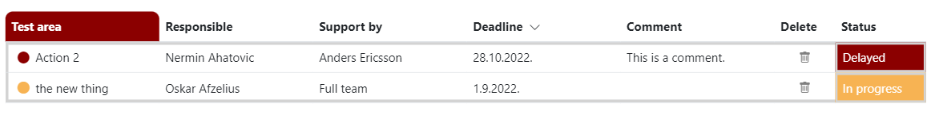

## Delete area of improvement flow

* Click on the edit button beside the best contribution to which area of improvement that you wish to delete



* A window opens containing editable fields and below them is the list of areas of improvement that belong to the chosen best contribution



* Click on the delete icon ⮾ on the right side of the title of area of improvement you wish to delete



* After clicking on the delete icon ⮾, a small window with a warning message as follows shows up if there are actions associated with the area of improvement: “Are you sure you want to delete this area of improvement? There are actions in it. After deleting an area of improvement, actions will be moved to section - No area of improvement.” Below this message there are two buttons visible: “Cancel” and “Delete anyway” button

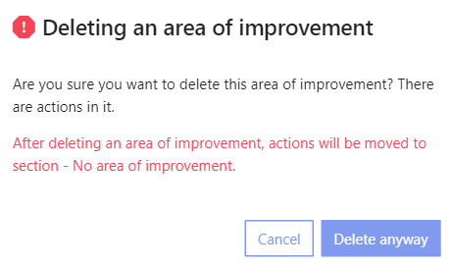

* Confirm this action by clicking on the “Delete anyway” button
* The area of improvement is deleted and all actions associated with it are moved to “No area of improvement” section
* Changes are saved and visible on the action plan

## Create action flow

* Click on the big circular floating + button in the bottom right corner and two options pop up: “Action” and “Idea”

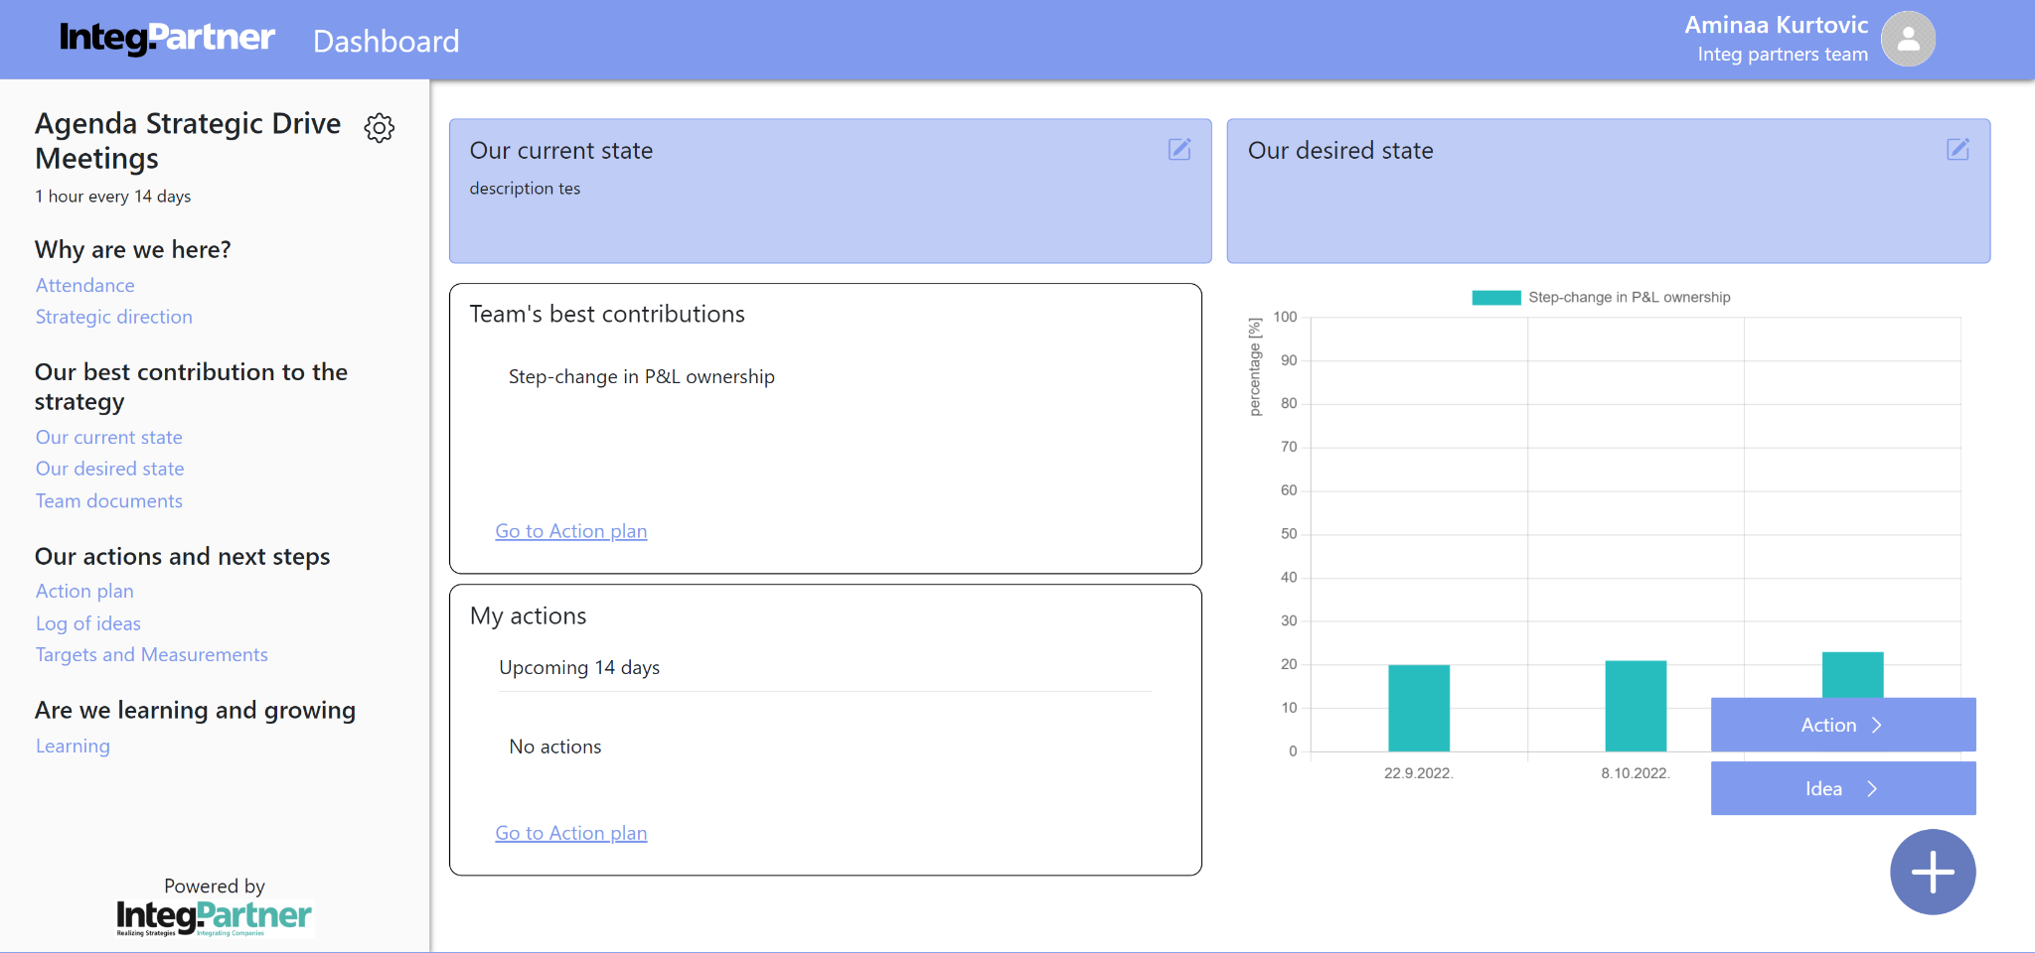

* When choosing the “Action” option a “Create new action” window is opened.

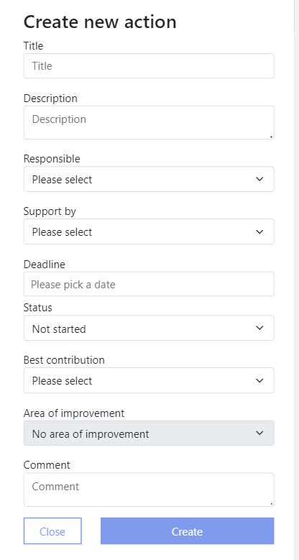

* Input the data about the action (title and best contribution are the only mandatory fields)
* Confirm this action by clicking on the “Create” button
* The new action is created and visible on the action plan

When creating an Action, improvement areas are limited to those from the selected best contribution. The "Responsible" and "Support by" drop-downs list all team members.

## Edit action flow

* Click anywhere on the row of the action you wish to edit and window opens from the right with preloaded data along with the “Close” and “Save” buttons

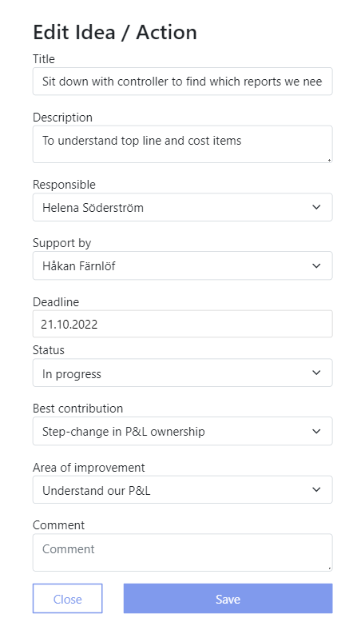

* Make intended changes
* Confirm this action by clicking on the “Save” button and form is automatically closed
* Changes are saved and visible on the action plan

## Delete action flow

* Click on the delete icon  in the delete column of the action you wish to delete



* After clicking on the delete icon , a small window with a warning message as follows shows up: “Are you sure you want to delete this action? Action will be permanently deleted!” Below this message there are two buttons visible: “Cancel” and “Delete anyway” button

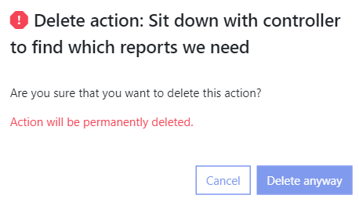

* Confirm this action by clicking on the “Delete anyway” button and a message pops up in the bottom left corner with the following content: “Action successfully deleted!”
* Action is deleted, changes are saved and they are visible on the action plan

## Filters

Filter buttons are on the right side of the action plan title. Users can filter the action plan by team members (person) or status, or both simultaneously.

Clicking a filter button allows users to select an option to filter actions in the best contributions accordingly. Areas with no respective actions remain visible.

When filtering by person, actions matching the “responsible” or “support by” columns are shown. The filter options include all team members.

When filtering by status, actions matching the “status” column are displayed. Status options are: not started, in progress, delayed, and done.

Filtering by both person and status displays actions where both the “responsible” or “support by” and “status” columns match the selected filters.

### Filtering action plan flow

* Click on chosen filter button and the drop-down menu shows up

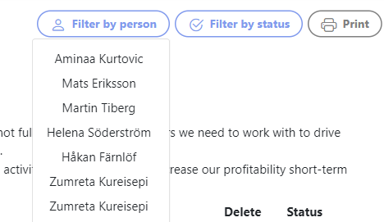

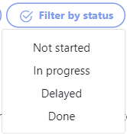

* Choose desired option
* The actions in all best contributions are automatically filtered and the only ones displayed are the ones that match the filter

# Log of ideas

Access the Ideas module by clicking on "Log of ideas" under "Our actions and next steps" in the sidebar. This module stores user-generated ideas that can be converted into actions to support the team's strategy. Ideas are displayed as post-its. All users, including super admin, company admin, and regular users, have access to this module and its functionalities.

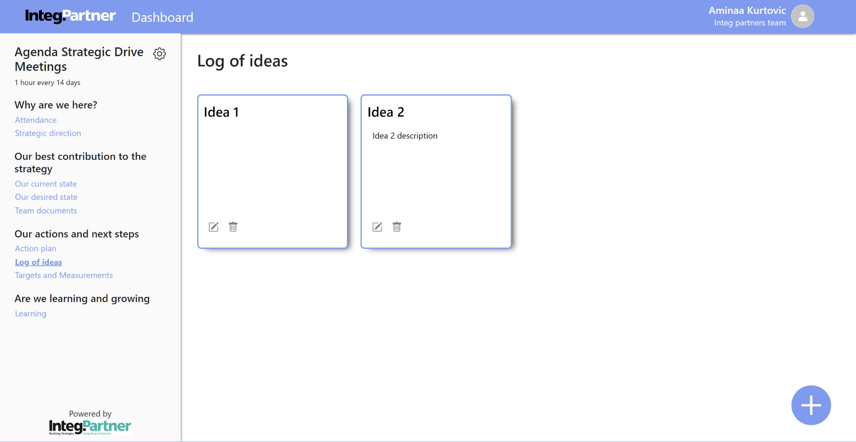

## Create idea flow

* Click on the big circular floating + button in the bottom right corner and two options pop up: action and idea



* Choose the “Idea” option and a window opens up with drop-down to choose idea module to which user wants to add new idea, title and description fields along with the “Close” and “Create” buttons

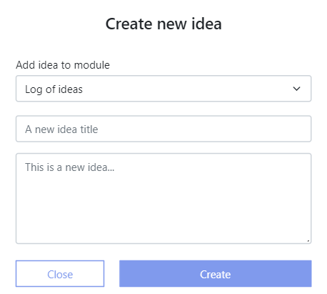

* Input desired data about the idea(title is the only mandatory field)
* Confirm this action by clicking on the “Create” button and a message pops up to notify you about successful action
* The new idea is created and visible on the idea module

## Edit idea flow

* Click on the edit icon  in the bottom left corner of an idea that you want to edit and a window opens with two editable fields and “Close” and “Save” buttons (the window has two tabs placed below the title: “This will stay an idea” and “Convert to action”, default and relevant tab in this case is “This will stay an idea” tab)
* Make your intended changes on either title or description of an idea (all other tabs are grayed out since they are not in focus)
* Confirm this action by clicking on the “Save” button and window automatically closes
* Changes are saved and visible on the idea module

## Delete idea flow

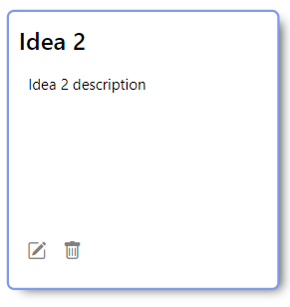

* Click on the delete icon  in the bottom left corner of the idea you wish to delete
* After clicking on the delete icon , a small window with a warning message as follows shows up: “Are you sure you want to delete this idea? The data will be permanently gone.” Below this message there are two buttons visible “Cancel” and “Delete anyway” button
* Confirm this action by clicking on “Delete anyway” button and the idea is deleted
* The changes are saved and idea is no longer visible in the idea module

## Convert idea to action

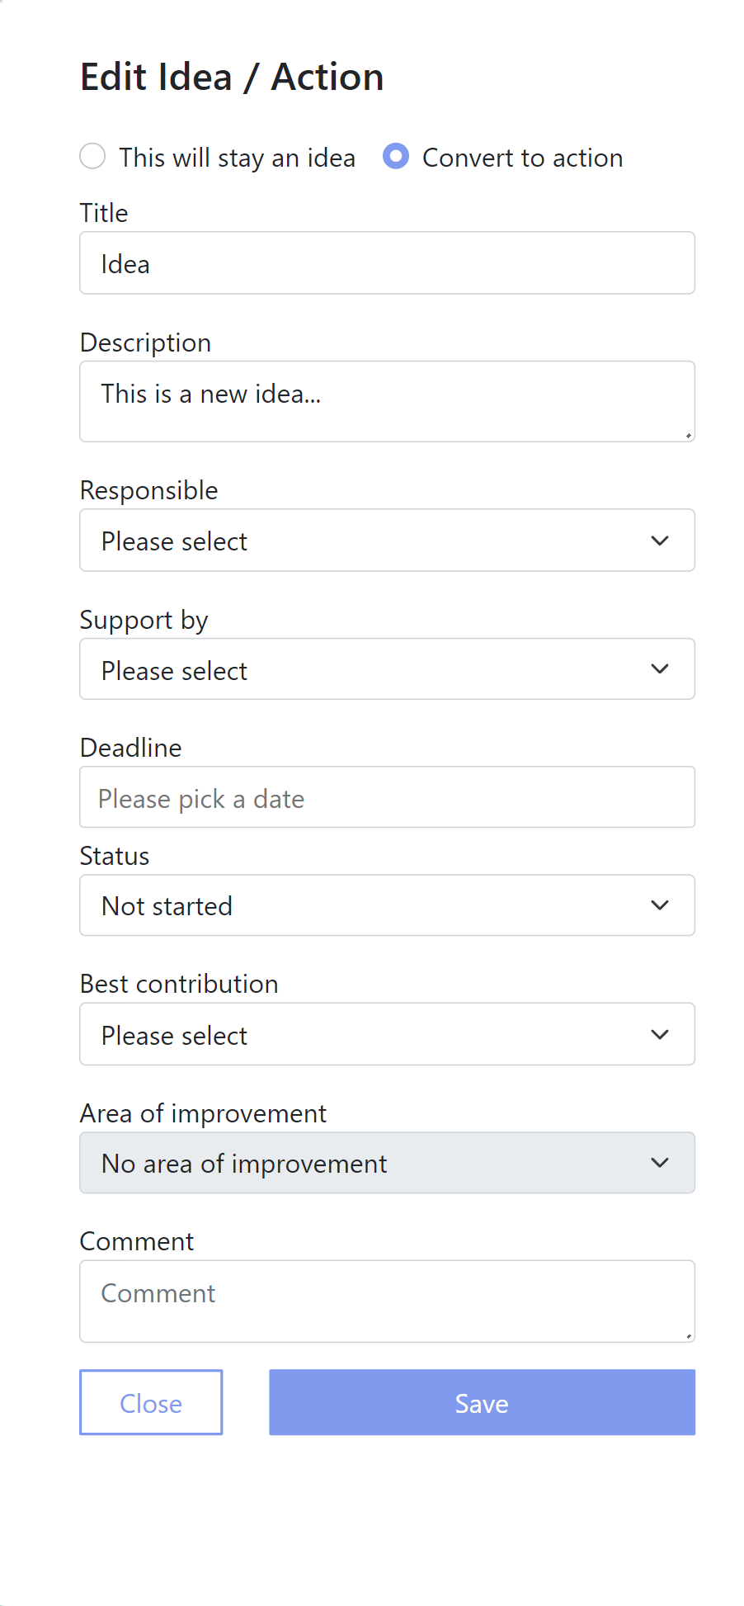

* Clicks on the edit icon  in the bottom left corner of the idea that you wish to convert to action and a window opens with two tabs placed below the title: “This will stay an idea” and “Convert to action”
* Select “Convert to action” tab and following fields are visible: title, description, drop-down to choose who is responsible for the action, drop-down to choose who is supporting team member for the action, date picker to pick deadline, drop-down to choose action’s status, drop-down to choose best contribution, drop-down to choose area of improvement, comment field along with the “Close” and “Save” buttons
* Enter the desired data about the action (title and best contribution are mandatory fields)
* Confirm this action by clicking on the “Create” button
* The new action is created and it’s now visible on the action plan paired with the best contribution

When converting an idea to action, improvements should focus on the selected best contribution. The dropdowns for "Responsible" and "Support" will list all team members.

# Targets and measurements

The Targets and Measurements module can be accessed by selecting the “Targets and Measurements” link under the “Our actions and next steps” section on the sidebar. Upon clicking this link, the Targets and Measurements module is displayed. This step precedes all subsequent functionalities related to the module, which will be described in the following sections but not included in the individual flow descriptions. The purpose of this module is to enable tracking of end goals related to optimal contributions through visual representation in the form of graphs. Goals are tracked and updated at each new meeting.

When a user accesses this module, if no best contributions have been added, an “Add best contribution to measurements” button will appear, accompanied by a message stating: “You need to add at least one best contribution before creating a new input.” If best contributions have already been added, the user will see them listed along with numerical values for the end goal and current state.

Below the list, there are “Add best contribution to measurements” and “Create new input” buttons. Additionally, a collapsible list of previous inputs is located below these buttons, and a graph is displayed at the bottom of the page.

Users of all roles have access to the Targets and Measurements module and all of its functionalities.

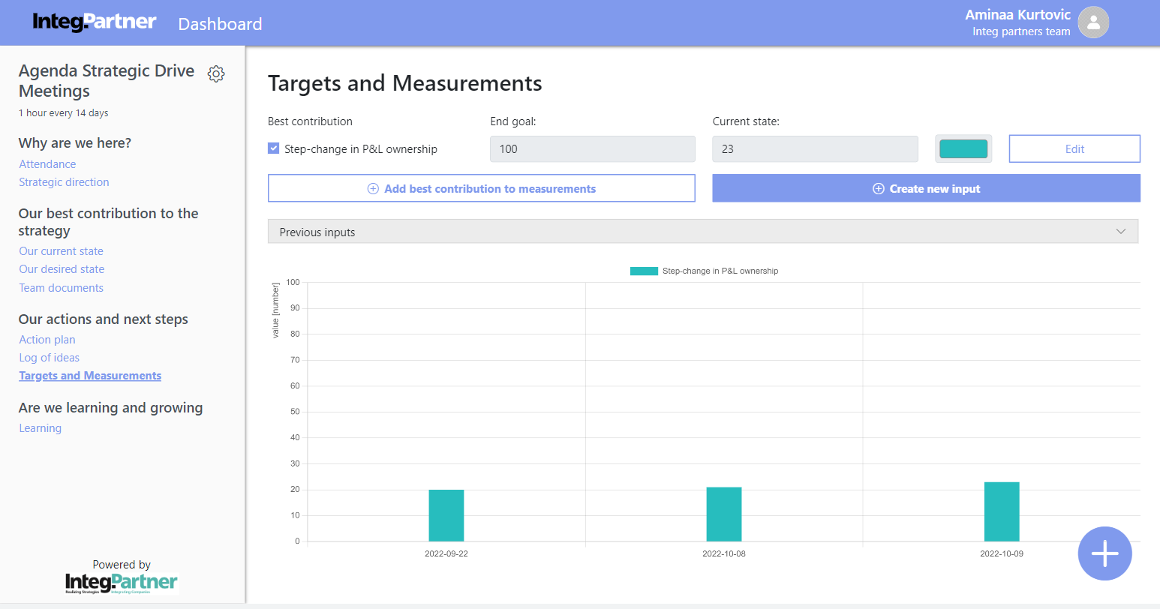

## Add best contributions to track future measurements

Users can add pre-existing best contributions to the targets and measurements module. They can track end goals, current states, and progress over time. End goals are represented numerically.

### Add best contributions to track future measurements flow

When the user clicks “Add best contribution to measurements,” a window appears with a drop-down list of all unadded best contributions from the action plan, an end goal field, a color picker for graph representation, and "Close" and "Save" buttons.

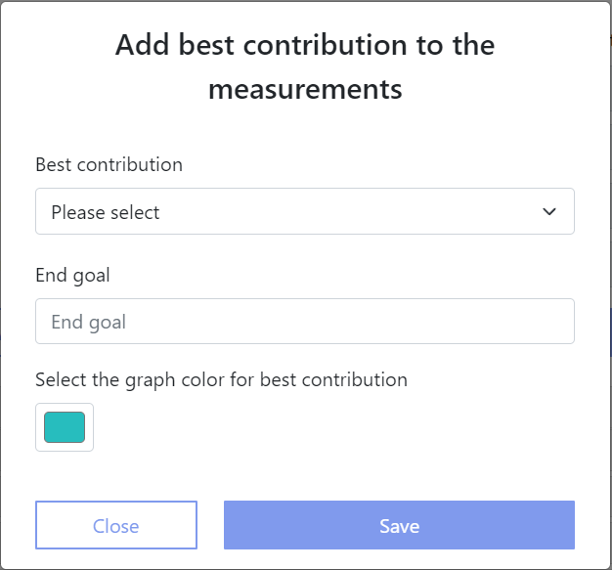

* Enter desired data (both best contribution and end goal are mandatory fields)
* Confirm this action by clicking on the “Save” button and the window automatically closes
* The new best contribution is added and is visible on the targets and measurements module

## Edit best contribution end goal flow

* User clicks on the “Edit” button on the right side of best contribution they wish to edit end goal for and window opens up with editable end goal numerical field along with the “Close” and “Save changes” button

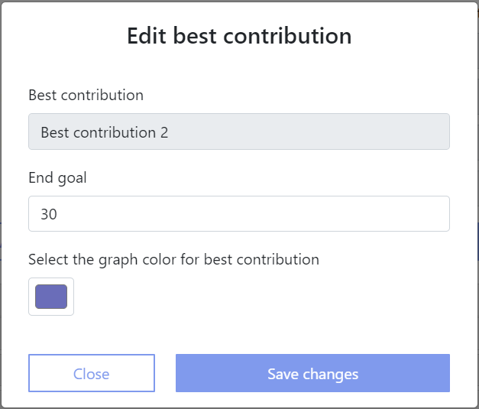

* Make intended changes
* Confirm this action by clicking on the “Save changes” button and the window is closed
* The changes are saved and they are visible on the targets and measurements module

## Create new input

Users can create new input for any contributions they have added to the module. Inputs are typically created approximately every 14 days, as meetings are usually held within that time frame.

### Create new input flow

* The user clicks on the “Create new input” button and window opens up with date picker to select date for inputs, list of best contributions with their respective “end goal” and “previous state” read-only fields and “current state” field.

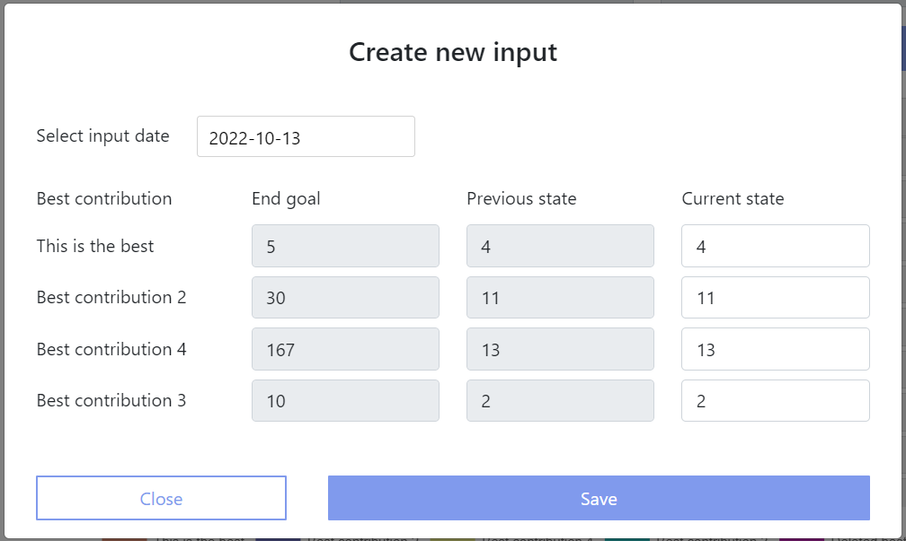

* Enter new data into “current state” fields for best contributions
* Confirm this action by clicking on the “Save” button and window closes
* Changes are saved and they are visible on the best contributions list and graph (previous state and current state of best contribution are updated which is visible if you open the “Create new input” form again)

## Previous inputs overview

Previous inputs are below the list of best contributions and the buttons “Add best contribution to measurements” and “Create new input”. The list of previous inputs is initially collapsed. To expand it, click the down arrow next to the “Previous inputs” title. Once expanded, all inputs are visible, marked by date, with options to delete or expand them. The most recent inputs appear at the top. Expanding an input shows the best contributions tracked at that time, including their end goal, previous state, and current state. Multiple inputs can be expanded simultaneously. To collapse them, click the up arrow.

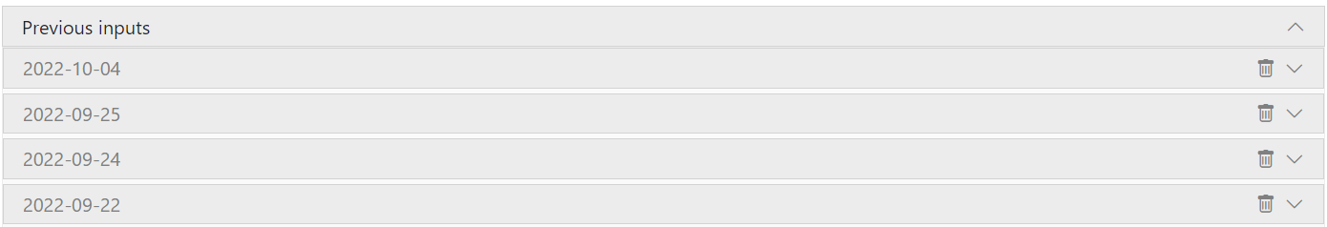

## Delete input flow

* Expand the list of previous inputs, then click on the delete icon  on right side of the date for the input you wish to delete



* After clicking on the delete icon , a small window with a warning message as follows shows up: “Are you sure you want to delete this input? Input data and measurements will be permanently deleted.” Below this message there are two buttons visible “Cancel” and “Delete anyway” button
* Confirm this action by clicking on “Delete anyway” button and input is deleted
* Changes are saved and they are visible on the previous inputs list

## Graph overview of previous inputs

Each best contribution has a checkbox for selection. Selected contributions will be included in the graph. If only one is selected, y-axis values reflect the end goal value; if multiple, they are shown as percentages. The top of the graph displays selected contributions and their colors.

The x-axis shows meeting dates and tracked contributions. Hovering over a bar reveals details such as input date, title, value, percentage, and end goal. Deleted contributions will display "Deleted best contribution" along with relevant info.

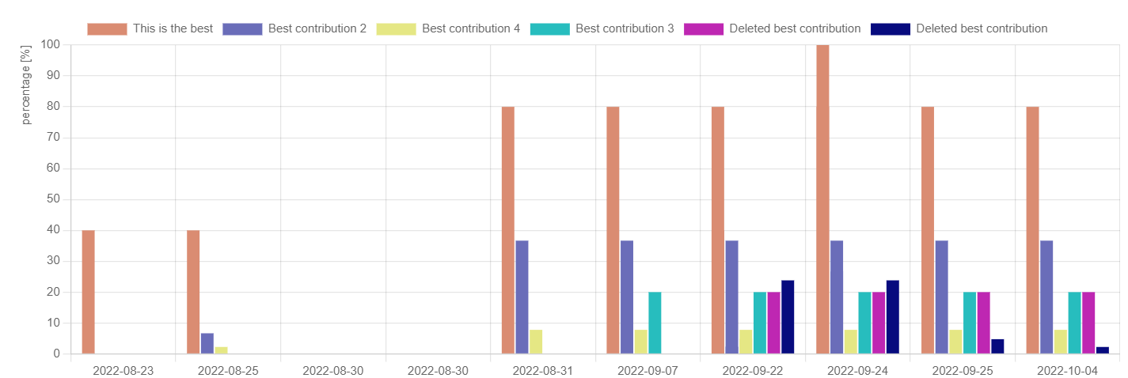

# Dashboard

The Dashboard is the central part of the home page. The top row features “Our current state” and “Our desired state” modules, both with edit icons leading to those modules. Below “Our desired state” module, there are “Team’s best contributions” and “My actions” sections.

“Team’s best contributions” showcases the best contributions in the action plan, with a scrollable list and a “Go to Action plan” link. “My actions” displays tasks for the logged-in user with upcoming deadlines in the next 14 days or overdue tasks. Tasks appear if the user is responsible or mentioned as support, including team-supported tasks. It is also scrollable with a “Go to Action plan” link.

The “Targets and measurements” module includes all added contributions and is part of the dashboard.

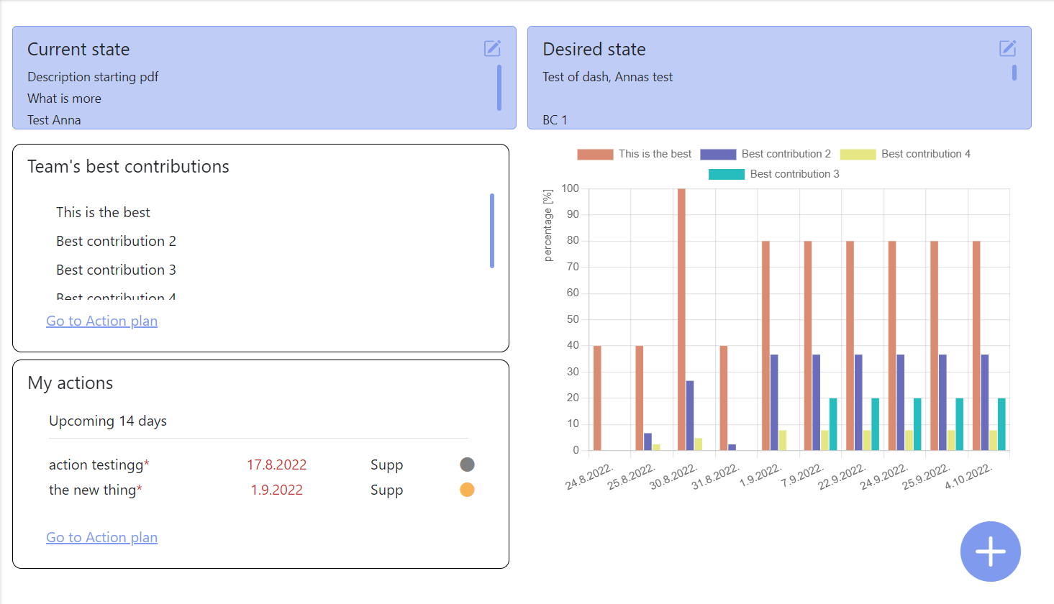

# Add new action/idea floating button

The floating button for adding a new action or idea is visible throughout the application, except when admins are editing the agenda or accessing administrator panels. Located in the bottom right corner, it allows users to add either an "Action" or an "Idea" by clicking on it. The relevant window will then open for the selected option. The processes for creating new actions and ideas were previously described.



# Switch language

Users are able to switch between two languages: English and Swedish.

## Switch language

* Click on your name in the upper right corner and drop-down menu shows up

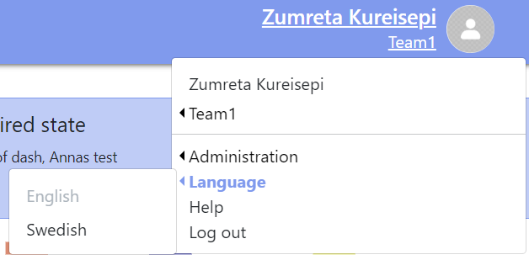

* Selects “Language” option and “English” and “Swedish” options become available
* Select the desired language
* Page content is now translated to the selected language

# Help

To request help, users can email the IntegPartner team. Click your name in the upper right corner, select "Help" from the drop-down menu, and a mailer will open with your email in the "from" field and support@tools.integpartner.com in the "to" field. You can then send an email to request assistance.

